# K-Freestanding

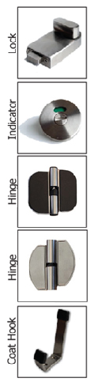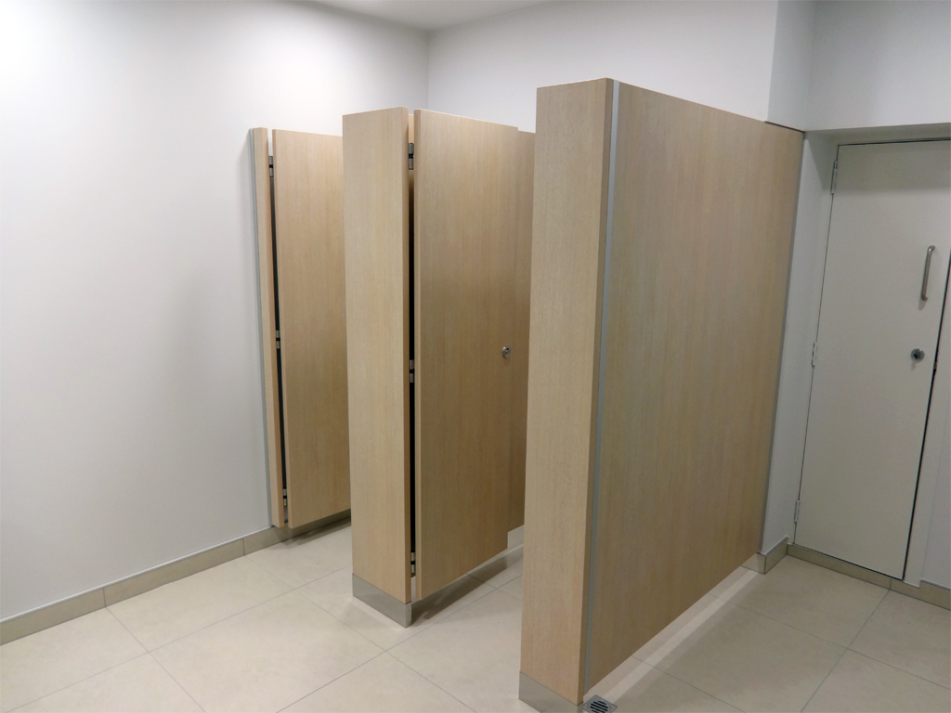The K-Freestanding is our top end system which requires no head-rail. It is only available in new buildings that meet the required criteria as it needs to be securely fastened to the floor. It offers peak performance in style and usability.

## Laminate to choose from:

High Pressure Laminates Low Pressure Laminates Compact Laminates  
KerMac Decorative Melteca KerMac Compact  
Laminex Melamine Laminex Compact  
Formica Structural Board

## Applications Features

Low moisture/dry area Stainless steel wrapped pedestal  
High end offices Anodised Aluminium channels  
Commercial Stainless Steel locks, coat hooks and fastenings  
 Rise and fall hinges

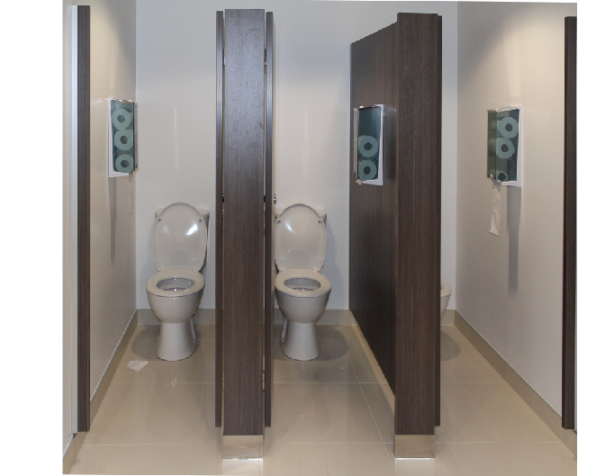

## Standard Materials

18mm/30mm thick MDF laminated board  
13mm Compact laminate  
Non-standard facing panels made to order  
For high humidity areas Compact available  
Edge-banded laminated board

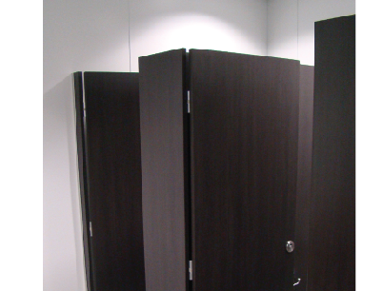Optional Accessories:  
Toilet roll holders  
Grab Rails  
Pull Handles  
Shower seats and brackets  
Paper towel dispenser  
Waste receptacles  
Powder coated aluminium trim

## Dimensions and installation

Width and depth vary to suit application  
Doors: Standard 560mm opening  
 Disabled 760mm minimum opening  
 Sliding doors on request  
Standard height is 1900mm with 100mm Stainless steel surrounds  
  
KerMac include installation within the Auckland region. Alternatively, cubicles can be flat packed and shipped anywhere in Australasia with installation instructions included.

## CAD drawings



Larger CAD Drawings available on [www.kermac.co.nz](http://www.kermac.co.nz) in PDF, DWG and DXF formats

PH: (09) 273 1524 | ADDRESS: Unit I, 9 Lady Ruby Drive, East Tamaki, Auckland | PO Box 51 964 Pakuranga, Auckland