# K-Floormounted

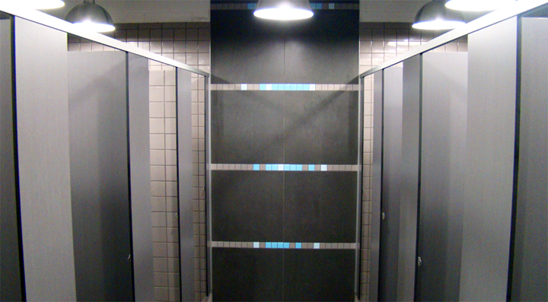The K-Floormounted system is our answer to style and stability. This means there a greater ability to use this system in different applications. While keeping the stylish and smooth lines of our latest design styles, the   
K-Floormounted system provides greater durability and stability with an overhead head-rail.

## Laminate to choose from:

High Pressure Laminates Low Pressure Laminates Compact Laminates  
KerMac Decorative Melteca KerMac Compact  
Laminex Melamine Laminex Compact  
Formica Structural Board

## Applications Features

High moisture areas  
Low moisture/dry area Stainless steel wrapped pedestal  
High end offices Anodised Aluminium channels  
Commercial Stainless Steel locks, coat hooks and fastenings   
Gym  
Function Centres

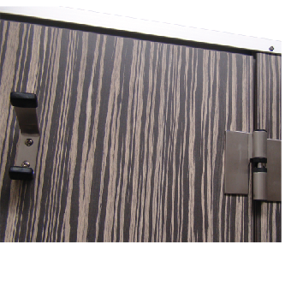

## Standard Materials

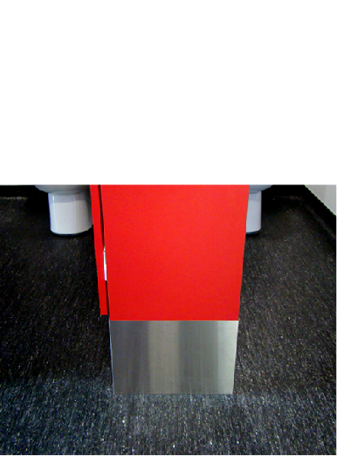18mm/30mm thick MDF laminated board  
13mm Compact Laminate  
Non-standard facing panels made to order  
For high humidity areas Interior Plywood available  
Edge-banded laminated board  
Optional Accessories:  
Toilet roll holders  
Grab Rails  
Pull Handles  
Shower seats and brackets  
Paper towel dispenser  
Waste receptacles  
Powder coated aluminium trim

## Dimensions and installation

Width and depth vary to suit application  
Doors: Standard 600mm opening  
 Disabled 800mm minimum opening  
 Sliding doors on request  
Standard height is 2000mm with 200mm blade wraps  
  
KerMac include installation within the Auckland region. Alternatively, cubicles can be flat packed and shipped anywhere in Australasia with installation instructions included.

## CAD drawings



Larger CAD Drawings available on [www.kermac.co.nz](http://www.kermac.co.nz) in PDF, DWG and DXF formats

PH: (09) 273 1524 | ADDRESS: Unit I, 9 Lady Ruby Drive, East Tamaki, Auckland | PO Box 51 964 Pakuranga, Auckland