# K-proform

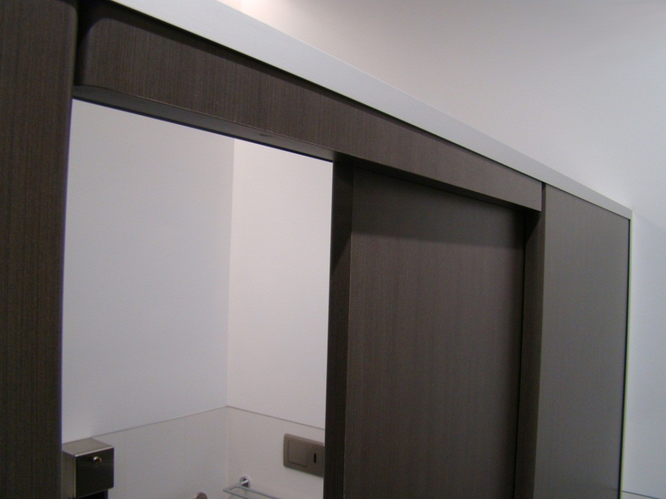The K-Proform system is our high end design. It is finished in Post-formed edges that give it that sleek styled look. Blade type pedestals raise it off the floor.



## Laminate to choose from:

High Pressure Laminates   
Wilsonart   
Laminex   
Formica   
Nevamar

## Applications Features

Low moisture/dry area Box Blade pedestal  
High end offices Anodised Aluminium channels  
Commercial Stainless Steel locks, coat hooks and fastenings   
Banks Rise and fall hinges  
Museums

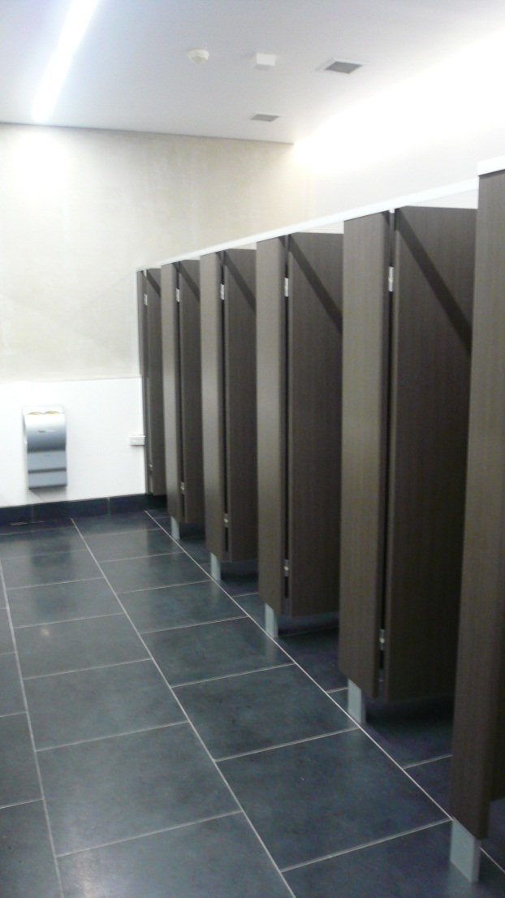

## Standard Materials

18mm/30mm thick MDF laminated board  
Non-standard facing panels made to order  
Edge-banded laminated board/Postformed edges

Optional Accessories:  
Toilet roll holders  
Grab Rails  
Pull Handles  
Shower seats and brackets  
Paper towel dispenser  
Waste receptacles  
Powder coated aluminium trim

## Dimensions and installation

Width and depth vary to suit application  
Doors: Standard 560mm opening  
 Disabled 760mm minimum opening  
 Sliding doors on request  
Standard height is 1900mm with 100mm floor clearance  
  
KerMac include installation within the Auckland region. Alternatively, cubicles can be flat packed and shipped anywhere in Australasia with installation instructions included.

## CAD drawings

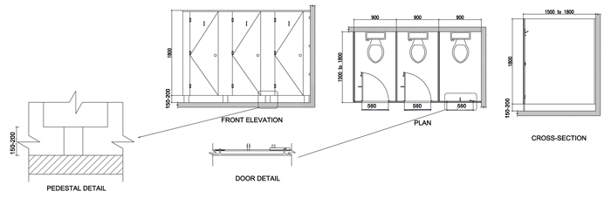

Larger CAD Drawings available on [www.kermac.co.nz](http://www.kermac.co.nz) in PDF, DWG and DXF formats

PH: (09) 273 1524 | ADDRESS: Unit I, 9 Lady Ruby Drive, East Tamaki, Auckland | PO Box 51 964 Pakuranga, Auckland