# K-Clashed

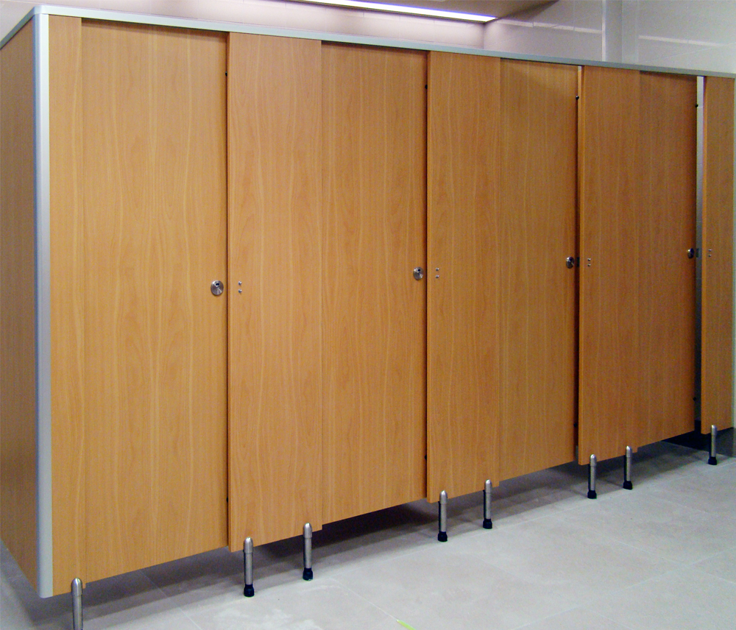The K-Clashed system comes with edge-banded laminated board and dual pedestals for extra strength and durability. It is best used in dry, low moisture applications such as schools or offices and where extra stability is important. It is available in a wide range of low and high pressure laminates and all the stainless steel and aluminium hardware is included.

## Laminate to choose from:

High Pressure Laminates Low Pressure Laminates  
KerMac Decorative Melteca  
Laminex Melamine  
Formica Structural Board

## Applications Features

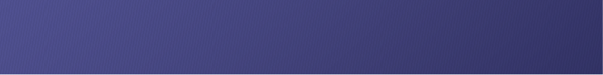Education Sector Aluminium or Stainless Steel Pedestals  
Commercial Offices Anodised Aluminium channels  
Dry, low humidity areas Stainless Steel locks, coat hooks and fastenings

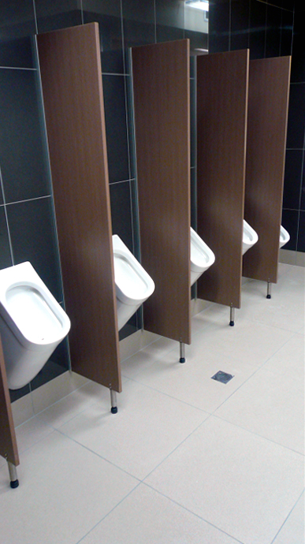

## Standard Materials

18mm thick MDF laminated board  
OR  
18mm Structural Board  
Non-standard facing panels made to order  
For high humidity areas Interior Plywood available  
Natural stain anodised aluminium edge trim

Optional Accessories:  
Toilet roll holders  
Grab Rails  
Pull Handles  
Shower seats and brackets  
Paper towel dispenser  
Waste receptacles  
Powder coated aluminium trim

## Dimensions and installation

Width and depth vary to suit application  
Doors: Standard 560mm opening  
 Disabled 760mm minimum opening  
 Sliding doors on request  
Standard height is 1950mm with 150mm floor clearance  
  
KerMac include installation within the Auckland region. Alternatively, cubicles can be flat packed and shipped anywhere in Australasia with installation instructions   
included.

## CAD drawings



Larger CAD Drawings available on [www.kermac.co.nz](http://www.kermac.co.nz) in PDF, DWG and DXF formats

PH: (09) 273 1524 | ADDRESS: Unit I, 9 Lady Ruby Drive, East Tamaki, Auckland | PO Box 51 964 Pakuranga, Auckland