# K-standard

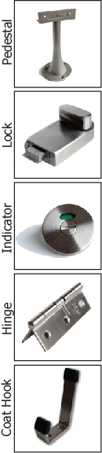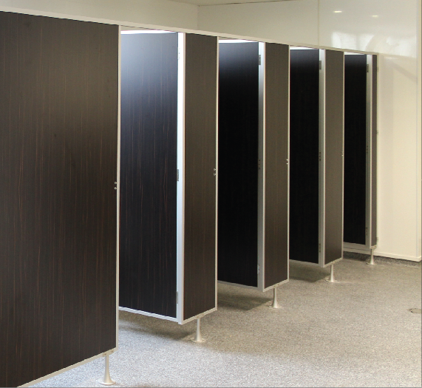The K-Standard system is a design regularly used by the commercial industry and is the industry standard. It is typically made with moisture resistant board that has been laminated to either a high or low pressure laminate and finished with aluminium clashed edgings, a powder coated aluminium pedestal and our stainless steel locks, coat hooks and fasteners.

## Laminate to choose from:

High Pressure Laminates Low Pressure Laminates  
KerMac Decorative Melteca  
Laminex Melamine  
Formica Structural Board

## Applications Features

Education Sector Aluminium or Stainless Steel Pedestals  
Commercial Offices Anodised Aluminium channels  
Dry, low humidity areas Stainless Steel locks, coat hooks and fastenings

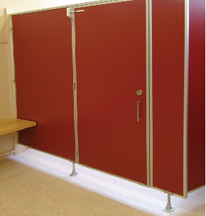

## Standard Materials

18mm thick MDF laminated board  
OR  
18mm Structural Board  
Non-standard facing panels made to order  
For high humidity areas Interior Plywood available  
Natural stain anodised aluminium edge trim

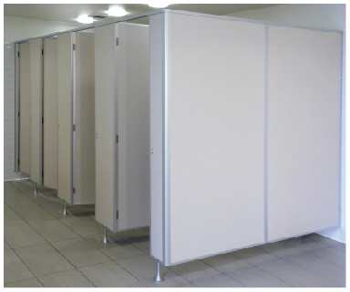Optional Accessories:  
Toilet roll holders  
Grab Rails  
Pull Handles  
Shower seats and brackets  
Paper towel dispenser  
Waste receptacles  
Powder coated aluminium trim

## Dimensions and installation

Width and depth vary to suit application  
Doors: Standard 600mm (560mm opening)  
 Disabled 800mm (760mm minimum opening)  
 Sliding doors on request  
Standard height is 1950mm with 150mm floor clearance  
  
KerMac include installation within the Auckland region. Alternatively, cubicles can be flat packed and shipped anywhere in Australasia with installation instructions included.

## CAD drawings



Larger CAD Drawings available on [www.kermac.co.nz](http://www.kermac.co.nz) in PDF, DWG and DXF formats

PH: (09) 273 1524 | ADDRESS: Unit I, 9 Lady Ruby Drive, East Tamaki, Auckland | PO Box 51 964 Pakuranga, Auckland