# K-Compact

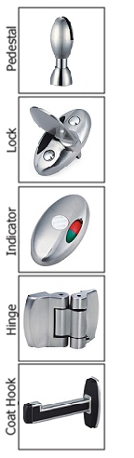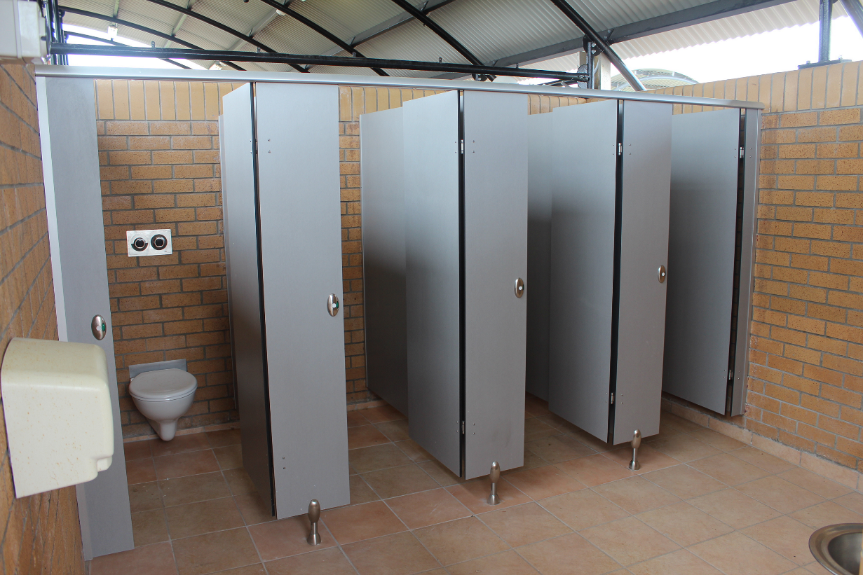The K-Compact system is constructed from compact laminate which is a strong, durable and moisture resistant material. While this system is strong, robust and widely applicable to many applications, it is also one of our affordable solutions. The use of edge-banding instead of anodised aluminium edge trim provides a smooth, modern form while lowering cost. K-Compact is an excellent choice for shower and wet area applications.

## Laminate to choose from:

Compact Laminates  
KerMac Compact  
Laminex Compact

## Applications Features

General Purpose Cast pedestal  
Wet or dry areas Anodised aluminium channels  
High Humidity Cast locks, coat hooks and SS fastenings   
Shower applications Bolt through Spring open or close hinges



## Standard Materials

13mm thick Compact laminated board  
Non-standard facing panels made to order  
Edges-Machined compact laminate

Optional Accessories:  
Toilet roll holders  
Grab Rails  
Pull Handles  
Shower seats and brackets  
Paper towel dispenser  
Waste receptacles  
**Not included unless otherwise stated**

## Dimensions and installation

Width and depth vary to suit application  
Doors: Standard 600mm opening  
 Disabled 800mm minimum opening  
 Sliding doors on request  
Standard height is 1975mm with 150-175mm floor clearance  
  
KerMac include installation within the Auckland region. Alternatively, cubicles can be flat packed and shipped anywhere in Australasia with installation instructions included.

## CAD drawings



Larger CAD Drawings available on [www.kermac.co.nz](http://www.kermac.co.nz) in PDF, DWG and DXF formats

PH: (09) 273 1524 | ADDRESS: Unit I, 9 Lady Ruby Drive, East Tamaki, Auckland | PO Box 51 964 Pakuranga, Auckland