General:
ALUCOLUX® is a pre-coil coated solid aluminium panel, used as an exterior or interior cladding and roof covering on new and/or refurbished buildings.
The material is manufactured by 3A Composites.
Product:
Technical Properties | ALUCOLUX®
Alloy | 3003
Temper | H24
Standard Thickness | 3mm  (Tolerance +/- 0.15mm)
Standard Widths | 1000mm,1250mm,1500mm,1575mm
Standard Length | </= 6000mm  (Tolerance +/-6mm)
Panel Weight | 8.1 Kg/m2
Tensile strength | 165-185 Mpa
Coating system | PVDF (70-30)
Coating thickness | 28-45 microns
*Available as flat panels and/or fabricated panels by the manufacturer
Paint finish:
ALUCOLUX® solid aluminium panel is available as an in-house pre-finished panel by the manufacturer with a fluorocarbon (PVDF/ FEVE) coating applied through a reverse roller coating process. The coating is backed up through a valid and approved license from the paint supplier to the manufacturer. The standard two and/or three coat system shall consist of a chromate conversation coating, an inhibitive primer, with a colour and top coat containing not less than 70% Polyvinylidene Fluoride (PVDF) resin by weight, and a total dry film thickness between 28-45 microns. The coated surface shall comply strictly with the ‘Specification for coated coils for exterior building applications’ issued by AAMA 2605 to achieve the quality label Category 1. The finished surface shall be factory protected with a self-adhesive peel off foil in a thickness of minimum 70 microns, tested to withstand at least 6 months exposure to local weather conditions without losing the original peel off characteristic or causing stains and other damages.
Application of the coating by means of spray coating in batch process after forming and shaping of the cladding elements shall not be permitted.
The reverse side of the cladding panel surface shall be in mill finish or service coat.

Colour/Gloss: As per ALUCOLUX® standard colour chart with approx. 30% gloss with max up to 80% according to the GARDNER scale.
Warranty: The panel is covered with a 15 years manufacturer’s warranty
Quality Certificate: The manufacturer shall comply with the highest standard of manufacturing, environmental, health and safety according to ISO 9001, ISO 14001 and BS OHSAS 18001.
Fabrication and Installation:
Flat panel supply
ALUCOLUX®, supplied as flat panels, should be fabricated and installed as per the recommendation from the manufacturer and in accordance with the design intent.
Ready to Install panels from the manufacturer’s in-house facility
ALUCOLUX® to supply pre-fabricated ready to install panels in designs, sizes and shapes provided. These value added services by the manufacturer include – Cutting the panel to size, routing the panel, notching the edges and folding into a tray system. If needed, fixing brackets and/or stiffeners can be added to the reverse side of the panel. These ready to install panels can be then directly fixed onto the sub-structures using specified fasteners by the fabricator/installers.
Flatness:
With a gloss of 30% to 80% according to the GARDNER scale, the cladding surface taken individually shall not have any irregularities such as oil canning, waves, buckles and other imperfections when viewed at any position but not less than an angle of 15 degrees to the true plane of the panel, with natural lighting of incident of not less than the same angle. This above is true only if the appropriate provisions are made to allow for differential thermal expansion within the fixing system.
Storage:
Panels shall be stored in a covered warehouse in vertical position, face to face respectively back to back, with adequate protection to prevent scratches and dents.
Cleaning and Maintenance:
Twice a year cleaning of the installed panels is recommended. The surfaces should be cleaned either manually using a soft brush or by means of a high–pressure cleaner(max 50 bar) with clean water. Do NOT use any strong alkaline cleaning agents. Do NOT clean surfaces heated by sun (>40oC) as the quick drying process may causes blemishes/stains.
Installation System options:
TRAY PANEL SYSTEM – HORIZONTAL JOINT DETAIL
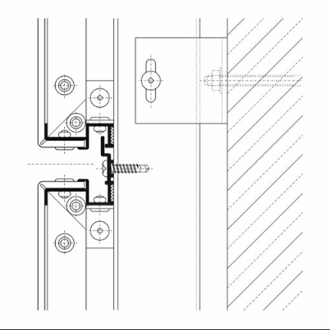
TRAY PANEL SYSTEM – VERTICAL JOINT DETAIL
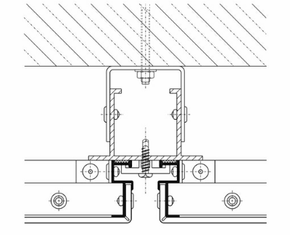

HOOK ON SYSTEM – HORIZONTAL JOINT DETAIL
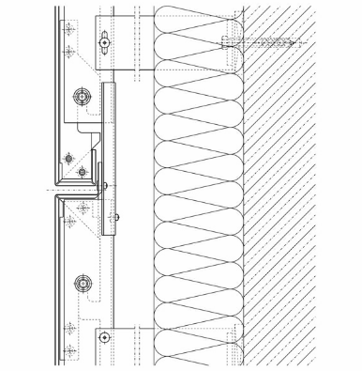
HOOK ON SYSTEM – HORIZONTAL JOINT DETAIL
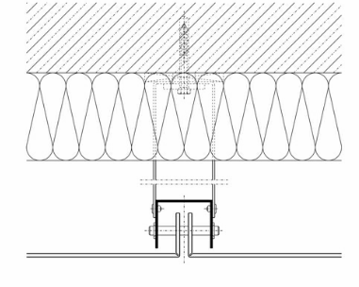
ALTERNATIVE METHODS DEVELOPED AND TESTED BY PROVIDERS OF CLADDING SYSTEMS

