#### Re: Performance of Light Steel Framed Housing in Severe Fires – a Brief Overview of Behaviour

**05 September 2012**

**To whom it may concern:**

Individual light gauge steel sections have very limited fire resistance if exposed directly to severe fires. This is because of their light cross section and complex shape which makes them susceptible to buckling modes of failure. However, where they are protected from direct fire exposure by suitable linings, light gauge steel members perform well. If the linings are breached, then the non combustibility of steel limits fire spread through the framing.

When a fire does breach the linings and impact directly onto the steel framing, the fire resistance of the overall framing system is very much greater than that of the individual members. Two examples of this have been seen in recent fires in modern steel framed houses and a very brief overview of these is now given.

Figure 1 shows the state of light steel roof trusses after a fully developed fire in the bedroom below which caused localised failure of the gypsum board ceiling. The fire was detected and suppressed before it spread out of the room of origin, which was a bedroom. The damaged trusses were replaced, along with the linings and the house returned to service. There was no spread of fire within the breached roof space and consequently the structural damage in the roof space was very localised.

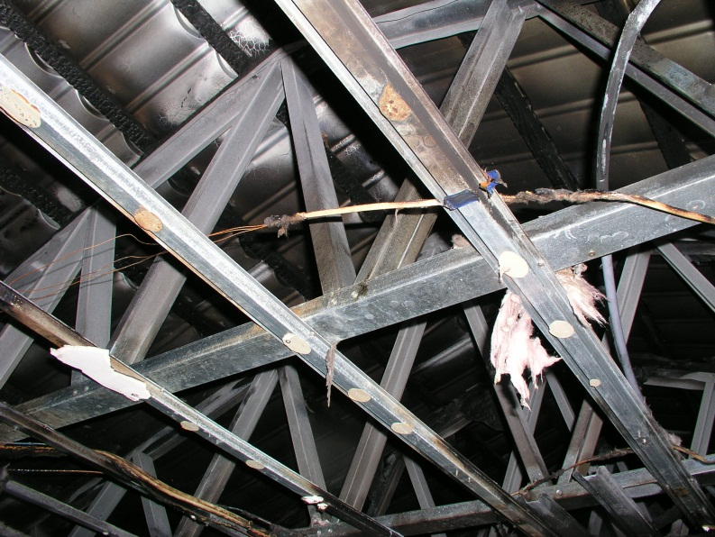

Figure 1 Light steel trusses above bedroom fire which breached the gypsum board ceiling

Although fire modelling of this enclosure was not undertaken, the writer’s experience is that the fire would have been of similar severity to that shown in the natural fire test undertaken in 2006 by Brown (Brown 2007) as part of a Master of Engineering project into the performance of steelwork partially protected by radiation barriers. The fire test shown in Figure 2 was the last of three tests undertaken on an enclosure typical of a single room in a building. The fire load was 405 MJ/m2 floor area, being that from (C/AS1 2005) for a house.

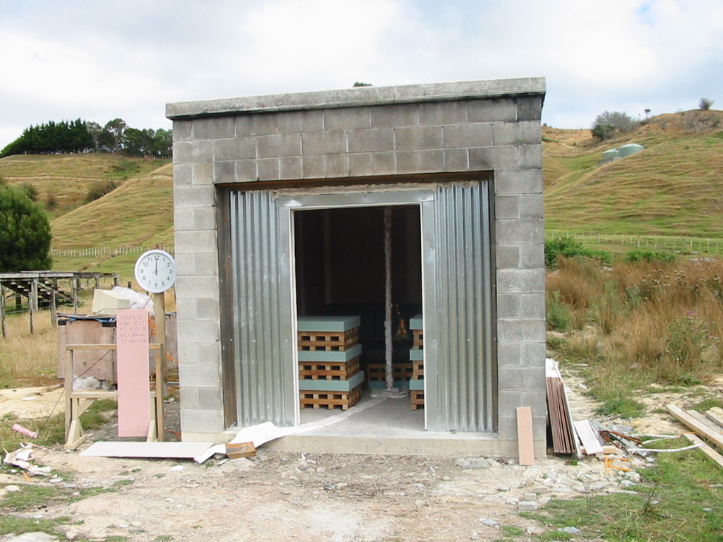

Figure 2 Natural Fire Test Setup

(from (Brown 2007))

The average time-temperature conditions reached in the test enclosure are shown in Figure 3. Temperatures peaked at between 900 and 1000 Deg C which is typical of low fire load fires in gypsum board lined compartments. In that test the linings did not fail and so temperatures remained higher in the test enclosure and low in the structural voids behind the linings.

Figure Fire and Steel Temperatures from Natural Fire Test in Figure 2

In the house fires shown in Figure 1 and in the second example described below, the linings were breached, resulting in temperatures reached in the ceiling void rapidly rising to over 600 Deg C locally while temperatures in the enclosure dropped to around the same level. In the first example, the fire was confined to the room of origin and the temperatures in the ceiling space away from the breach in the ceiling linings remained relatively low; the author’s estimate of not more than 200 to 300 Deg C.

The second case history described below was much more severe. In that case the fire started in an open plan kitchen/lounge/dining room area while the occupants were away As a result, half of the house was fully burned out with extensive smoke damage throughout the rest of the rooms. Figure 4 shows the view of the house from the front and back.

|  |  |
| --- | --- |
|  |  |

(a) (b)

Figure 4 View of burned out light steel frame house 2011; (a) from front and (b) from back

The fire conditions in the area of origin of this house would have been as severe as those shown in Figure 3. The condition of this region, looking from the dining room across the kitchen to the lounge, is shown in Figure 5 (a) with the close-up of the truss steelwork in Figure 5 (b).

|  |  |
| --- | --- |
|  |  |

(a) (b)

Figure 5 View of the interior looking at the fire origin (a) and close-up of roof steelwork in that region (b)

The surface condition of the steel framing showed extensive loss of the online coated zinc layer, indicating that temperatures had reached over 600 Deg C in the ceiling void for an extended period of time.

The performance of the steelwork under these high temperatures was very good. At the time the author visited this building it was raining heavily and the roof was still watertight, except where the fire service had broken through the roof to gain access to the fire. The roof truss steelwork was still intact and supporting the roof including over the open plan lounge/kitchen/ dining room area with clear open spans of up to 6 metres in two directions. The timber battens to which the steel roof tiles were attached had charred through and mostly disappeared in this region but the tiles were still in place.

The lack of combustible material in the roof space meant that the wing of the house furthest from the fire origin did not suffer heat damage, as the fire could not spread through the ceiling void. The smoke damage in that region, coupled with the extensive damage to the interior throughout most of the house meant that the house was to be replaced, unlike the first example which was repaired.

In a typical timber framed house, the quantity of combustible material is approximately the same as the quantity of occupant fire load. For a fire which is sufficiently severe to penetrate the linings to a large extent prior to being suppressed, this effectively doubles the fire load and hence the structural fire severity. The light timber framing when exposed to the temperatures of between 600 Deg C and 1000 Deg C, will typically burn through in around 10 to 15 minutes, resulting in partial or total collapse of the roof.

The lower fire load in the steel framed house and the superior strength and stiffness of the structural system during the fire were both factors in keeping the house substantially intact throughout the fire and in preventing the fire spread throughout the house. That allowed much of the occupant’s contents from the half of the house remote from the fire to be salvaged, even though the house was replaced.

There is nothing special about this house or the behaviour of the fire and so the robust behaviour of this steel framed house in this severe fire would be typical of fires in steel framed houses.

That concludes this brief overview of the behaviour of steel framed houses in severe fires.

Dr G Charles Clifton

Associate Professor of Civil Engineering

#### References

**Brown, N. C. (2007). Steelwork partially protected from post-flashover fires in gypsum plasterboard lined compartments. Christchurch, University of Canterbury School of Engineering.**

**C/AS1 (2005). Compliance Document for Fire Safety, C/AS1. D. o. B. a. Housing, Department of Building and Housing.**